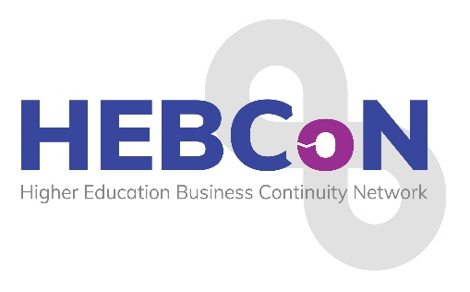
2026 Conference Programme
25th – 26th February 2026

Wednesday 25th February 2026

8.00pm: WELCOME AND DRINKS RECEPTION – Mezzanie Area, Crowne Plaza Hotel, Newcastle

Thursday 26th February 2026

8.40-9.00: REGISTRATION & COFFEE/TEA

9.00-9.10: Conference Welcome: Sarah Rowe, HEBCoN Chair - Northumbria suite

9.10-10.10: Kate Foulsham, Business Resilience Lead - Business Continuity, BA

10.10-11.10: When Cyber Hits the Physical World: A Real-Time BC/DR Exercise Philip Ridley, CyberOne

11.10-11.30: TEA & COFFEE BREAK

11.30-12.30 Mark Webster, Head of Risk and Resilience, UCAS

12.30-1.30: LUNCH

1.30-2.30pm: From scenario planning to policymaking: a practical workshop with Charlie Ogilvie, Deputy Director of Policy, Universities UK

2.30-2.50: TEA & COFFEE BREAK

2.50-3.50pm: Carol Prokopyszyn, Chief Financial Officer, University of Manchester

3.50-4.50pm: James Coe, Senior Partner and Head of Higher Education, Counterculture, and Contributing Editor for WonkHE

4.50-5.00: Summary and Closing Comments: Sarah Rowe, HEBCoN Chair

7.00-7.30 Drinks Reception, Mezzanine Area
7.30-23.00: Gala Dinner, Planet, Crown Plaza Hotel

Friday 27th February 2026

6.30 – 10am BREAKFAST and Depart

Thank you to our 2026 Conference Sponsors


