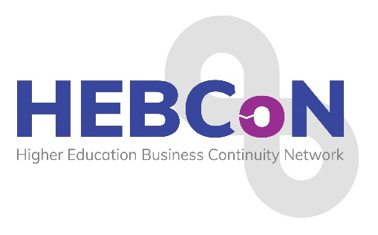
2026 Conference Programme
25th – 26th February 2026

Wednesday 25th February 2026

8.00pm: WELCOME AND DRINKS RECEPTION – Mezzanie Area, Crowne Plaza Hotel, Newcastle

Thursday 26th February 2026

8.40-9.00: REGISTRATION & COFFEE/TEA

9.00-9.10: Conference Welcome: Sarah Rowe, HEBCoN Chair - Northumbria suite

9.10-10.10: Business Continuity at British Airways, Kate Foulsham, Business Resilience Lead - Business Continuity, BA

10.10-11.10: When Cyber Hits the Physical World: A Real-Time BC/DR Exercise Philip Ridley, CyberOne

11.10-11.30: TEA & COFFEE BREAK

11.30-12.30: Mark Webster, Head of Risk and Resilience, UCAS

12.30-1.30: LUNCH

1.30-2.30pm: From scenario planning to policymaking: a practical workshop with Charlie Ogilvie, Deputy Director of Policy, Universities UK

2.30-2.50: TEA & COFFEE BREAK

2.50-3.50pm: Carol Prokopyszyn, Chief Financial Officer, University of Manchester

3.50-4.50pm: What happens when nobody comes to save us? Lessons about change when it seems impossible. James Coe, Senior Partner and Head of Higher Education, Counterculture, and Contributing Editor for WonkHE

4.50-5.00: Summary and Closing Comments: Sarah Rowe, HEBCoN Chair

19.00, Pre dinner drinks, Mezzanine reception area
19.30-23.00: Award Dinner, Planet, Crown Plaza Hotel

Friday 27th February 2026

06.30-10am – Breakfast and Depart

2026 Conference Speakers

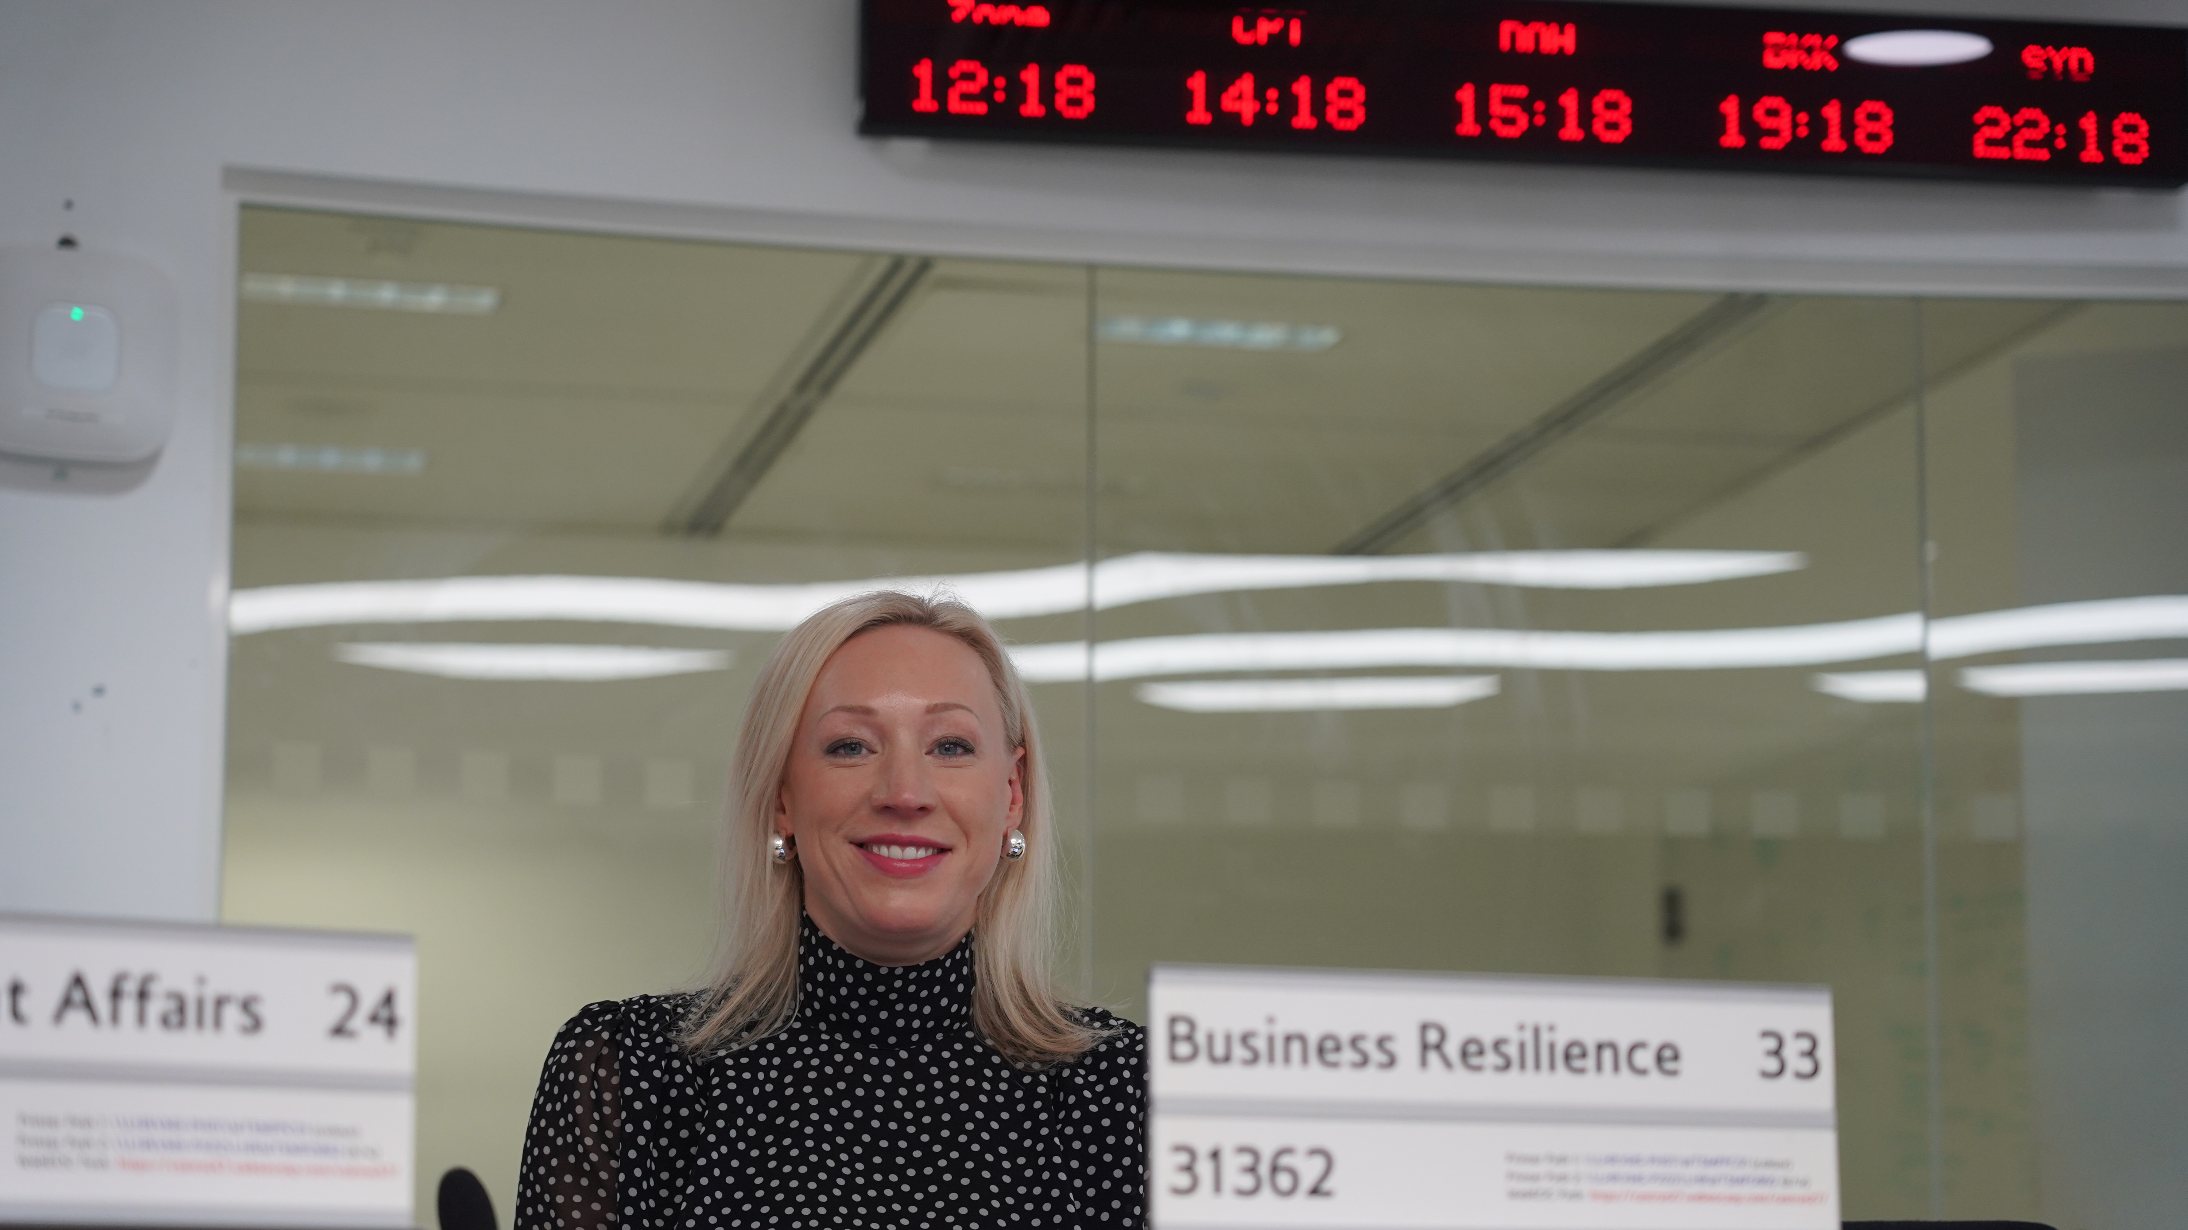

Kate Foulsham, Business Resilience Lead – Business Continuity, British Airways

Kate Foulsham MBCI is the Business Resilience Lead for Business Continuity at British Airways, where she leads the company’s business continuity management system and works with critical functions and key suppliers to ensure robust, well-tested plans are in place. Her work spans business impact analysis, scenario-led exercising, supplier resilience, and integration with IT disaster recovery. Kate also contributes to British Airways’ Crisis Management Team, helping ensure the organisation is prepared to activate a coordinated, humanitarian response during serious incidents.
Passionate about practical, user-centred resilience, she champions simple, usable plans, measurable outcomes, and continual improvement aligned to recognised best practice. She also oversaw the creation of a bespoke application to house Business Impact Analysis and Business Continuity Plans after identifying that no market solution met the needs of a busy, complex operation like British Airways.
Kate is also leads the BCI London Chapter.

 Philip Ridley, CyberOne Security
Philip is a senior cyber security leader with over 20 years of experience in safeguarding enterprise environments, driving strategic security initiatives and managing high-performing teams. Partnering closely with boards and executive teams, he has aligned security programmes to business outcomes, maintained ISO/IEC 27001 and ISO/IEC 22301 governance, implemented and renewed security frameworks, strengthened third-party risk management, and run executive and operational tabletop exercises, embedding lessons into playbooks, crisis communications, and decision authorities. A regular speaker at group-wide and international events, he is known for turning complexity into clear, measurable progress.

 Mark Webster, Head of Risk and Resilience, UCAS

As Head of Risk and Resilience at UCAS, Mark leads strategic resilience for the national admissions service. Mark has over a decade of experience, having previously developed the risk, business continuity, and crisis management culture at the University of the West of England, Bristol.
Mark’s leadership extends across the sector having served as Chair of HEBCoN from 2017 to 2019 and leading the Wales and South West Group until 2025.
Mark’s career began in environmental sustainability, graduating from Newcastle University in 1999 and working at Berwick-Upon-Tweed Borough Council, Northumbria University and Newcastle City Council in Environmental Management roles.
When it comes to the future, he believes that if you’re not confused, you’re not paying attention.
​

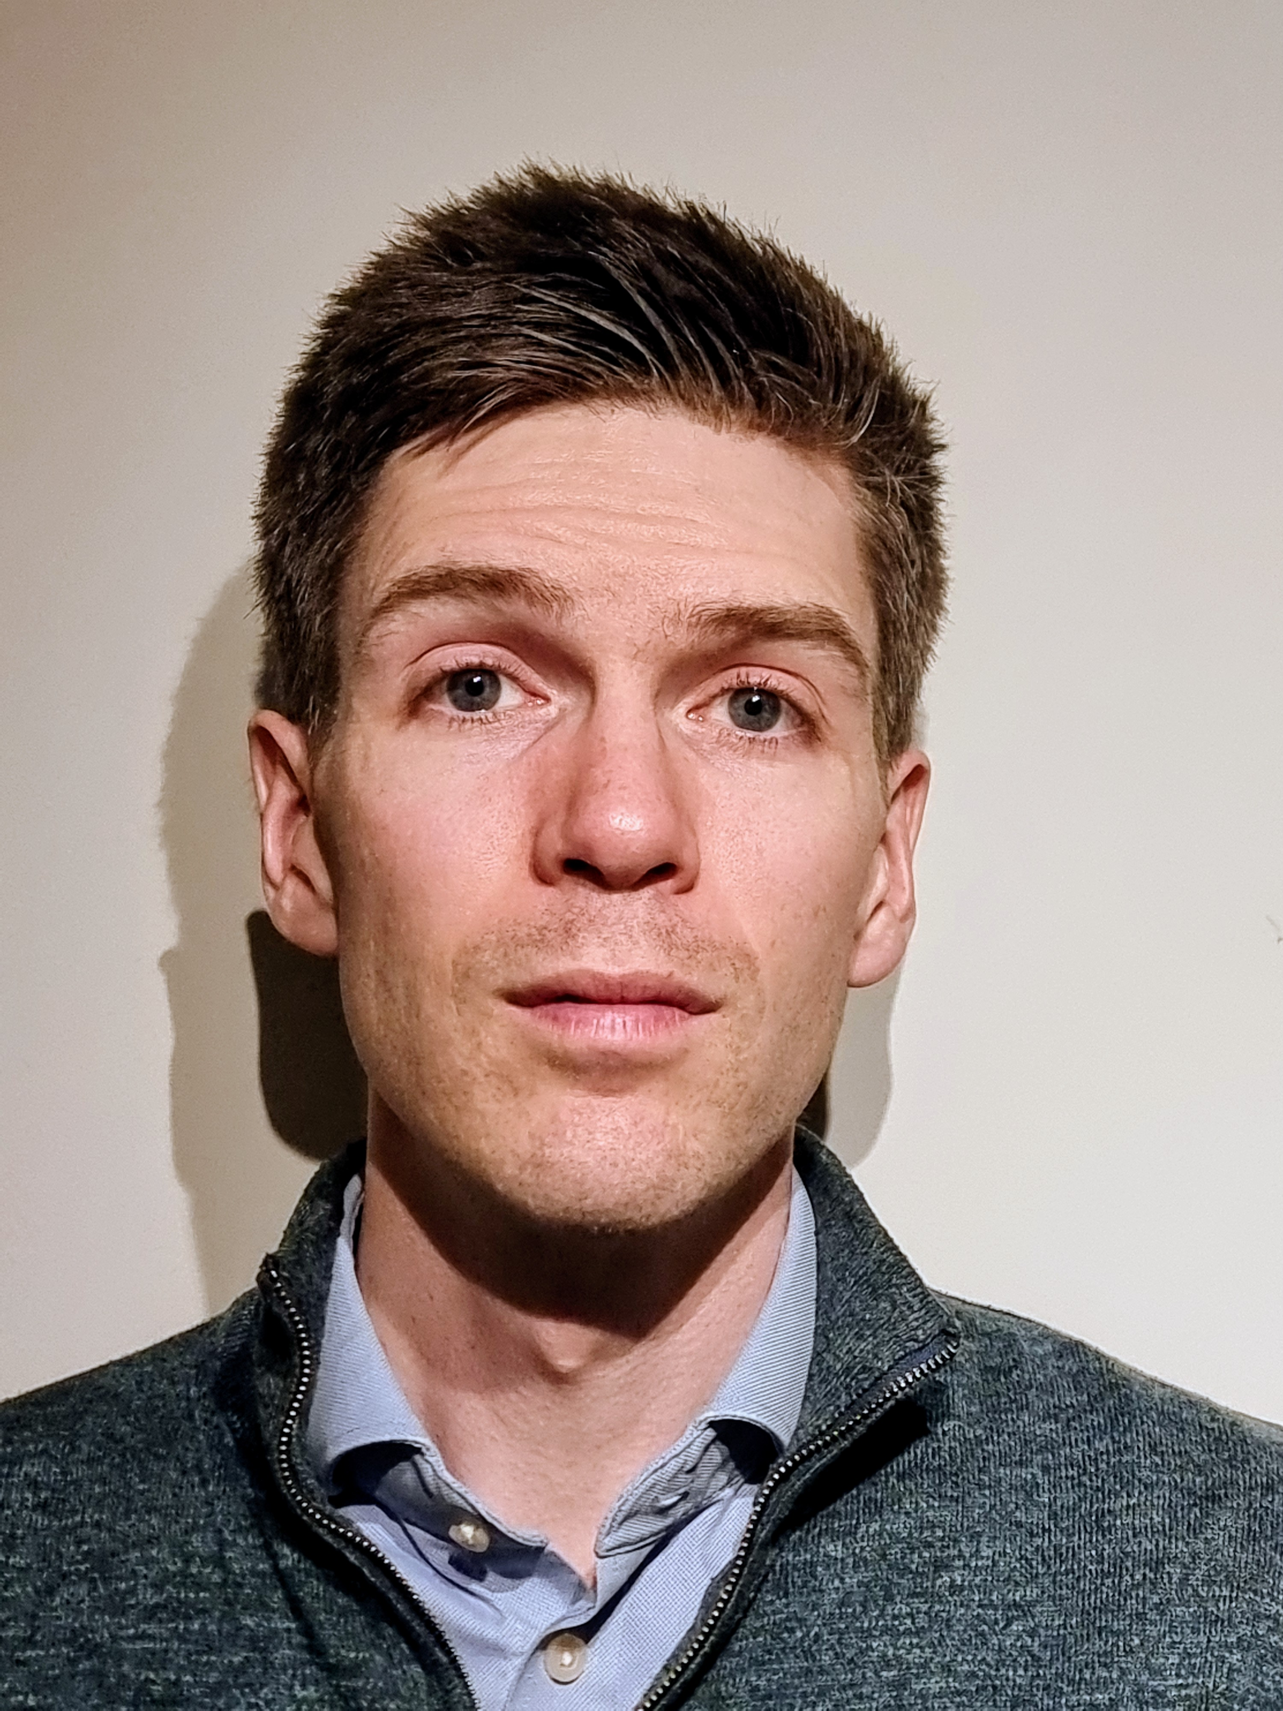 Charles Ogilvie, Deputy Director of Policy, Universities UK

Charlie is Deputy Director, Funding and Regulation Policy at Universities UK. He brings over a decade of experience working in UK government analysis and policy, covering education, justice and economic growth. He's particularly interested in where policy meets reality, so is very much looking forward to meeting HEBCoN members to learn more.

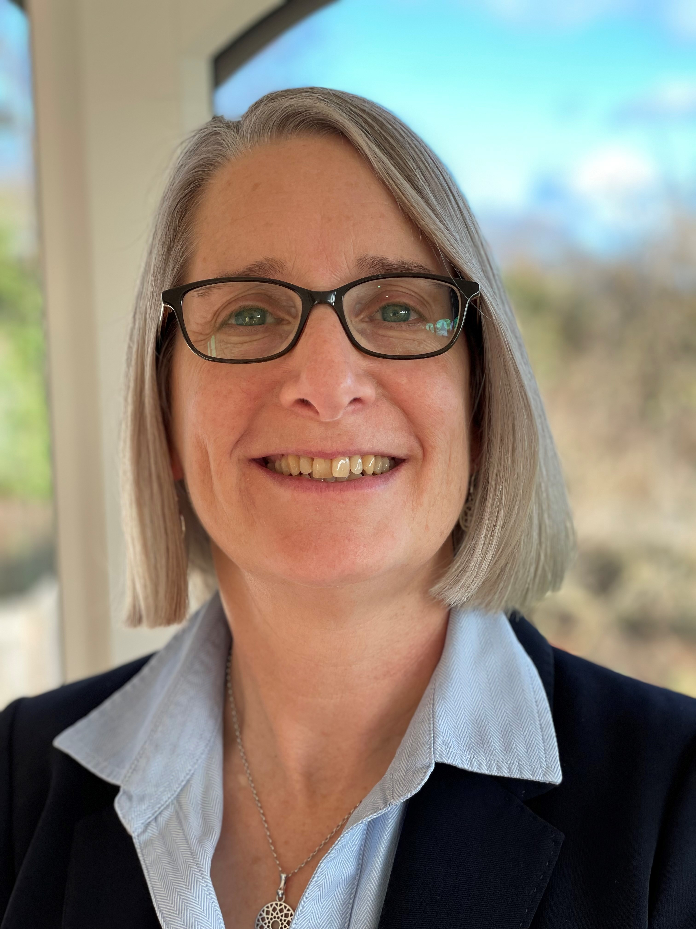

Carol Prokopyszyn, Chief Financial Officer, University of Manchester

Carol is the Chief Financial Officer at the University of Manchester. She joined in June 2022 from the University of Dundee, where she was the Director of Finance. Carol has worked in higher education for over 16 years, including as Deputy Director of Finance at Loughborough and Leicester. She is a chartered accountant, qualifying with PWC and has extensive commercial experience in the retail sector including international growth, investor relations and property.
Carol’s leads with ‘relationship building’ as her dominant leadership strength. She loves working closely with others to achieve a goal, developing individuals and fitting teams together to achieve more.
Carol continues to hold onto the notion that she might start running again, but the most likely answer will be more walks in Derbyshire!

 James Coe, Senior Partner and Head of Higher Education, Counterculture and contributing Editor for WonkHE
James is senior partner at Counterculture Partnership LLP where he leads the organisation’s work in higher education. He has worked on issues ranging from strategy and governance, to international partnerships, to the big policy debates on higher education. He is the author of a book on the future of higher education, the associated editor for research and innovation at Wonkhe, and proud to be from the UK’s 7th fastest growing economy, Darlington.

Thank you to our 2026 Conference Sponsors


