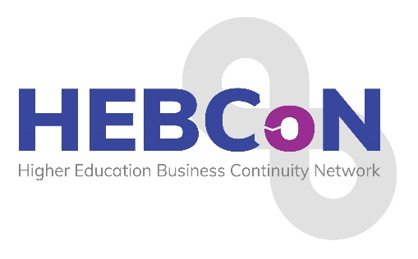
2026 Conference Programme
25th – 26th February 2026

Wednesday 25th February 2026

8.00pm: WELCOME AND DRINKS RECEPTION – Crowne Plaza Hotel, Newcastle – Mezzanine area

Thursday 26th February 2026

8.40-9.00: REGISTRATION & COFFEE/TEA

9.00-9.10: Conference Welcome: Sarah Rowe, HEBCoN Chair – Northumbrian Suite

9.10-10.10: Title TBC, Kate Foulsham, Business Resilience Lead - Business Continuity, BA

10.10-11.10: TBC

11.10-11.30: TEA & COFFEE BREAK

11.30-12.30: Title TBC, Mark Webster, Head of Risk and Resilience, UCAS

12.30-1.30: LUNCH - Hawthorns

1.30-2.30pm: Scenario planning session with UUK, Charlie Ogilvie, Deputy Director of Policy, Universities UK

2.30-2.50: TEA & COFFEE BREAK

2.50-3.50pm: Title TBC, Carol Prokopyszyn, Chief Financial Officer, University of Manchester

3.50-4.50pm: Horizon Scanning Session, James Coe, Senior Partner and Head of Higher Education, Counterculture, and Contributing Editor for WonkHE

4.50-5.00: Summary and Closing Comments: Sarah Rowe, HEBCoN Chair

7.00:Pre dinner drinks on the Mezzanine area
7.30 - 23.00: Award Dinner, The Planet Suite,Crown Plaza Hotel

Friday 27th February 2026

9.30-10.30: BREAKFAST & NETWORKING IN Hawthorns

Thank you to our 2026 Conference Sponsor



