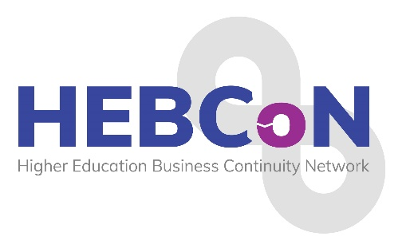

**2025 Conference Programme**

5th – 7th March 2025

**Hyatt Regency Manchester**

Date: 5th March 2025

**6.30pm: INFORMAL MEET UP –** Bar area

**7.30pm: INFORMAL BUFFET DINNER** – Burgess Room

Date: 6th March 2025

**8.40-9.00: REGISTRATION & COFFEE – outside Foster & Robinson Room**

**9.00-9.10: Conference Welcome:** Sarah Rowe, HEBCoN Chair

**9.10-10.10: TBC - Engaging your executives,** Patrick Hackett, Registrar, University Secretary & Chief Operating Officer, University of Manchester

**10.10-10.50: Round Table discussion on Martyn’s Law**

**10.50-11.10: TEA & COFFEE BREAK**

**11.10-12.10: Title tbc – human factors and cyber risk,** John Scott, Certified Instructor, SANS Institute

**12.10-1.10: LUNCH – outside Foster & Robinson Room**

**1.10-2.10: Professional Development Session,** Leadership Consultant & Coach,Kim Newton-Woof

**2.40-3.40pm: TBC?????**

**3.40-4.00: TEA & COFFEE BREAK**

**4.00-5.00: Keynote speaker: Beyond Resilience: Overcoming the Psychological Allergy to Uncertainty,** Graham Norris

**5.00-5.10: Summary and Closing Comments:**  **Sarah Rowe, HEBCoN Chair**

**6.30: Meet in hotel reception to walk to Museum for Award dinner**

**7.00-7.30: Pre Dinner reception drinks**

**7.30-23.00: Award Dinner, Museum of Manchester**

**Please join us!**

Date: 7th March 2025

**9.30-10.30 BREAKFAST in restaurant**

**10.30-11.30 Critical Arc, case studies – in Forest & Robinson room**